Error Analysis and Iterative Improvements of DeBERTa
The best-performing model in this project was built on the DeBERTa v3 XSmall architecture, fine-tuned in a multi-task setup using the microsoft/deberta-v3-xsmall checkpoint, to classify emotions from television show transcript. It predicts three emotion-related tasks simultaneously: primary emotions (e.g., Happiness, Anger), secondary emotions (e.g., Pride, Curiosity), and emotional intensity (Mild to Overwhelming). Chosen for its strong contextual understanding and efficiency, this model achieved the highest F1 score on the test set for primary emotion classification and showed strong performance in capturing both broad and nuanced emotional signals.
This document presents a focused error analysis, beginning with a brief look at dataset quality and initial model behaviour. We then assess the model’s performance across each iteration and summarize key error patterns. These findings highlight how our iterative changes improved predictions and reveal remaining challenges, informing future improvements and practical use.
  - Dataset Quality Assessment
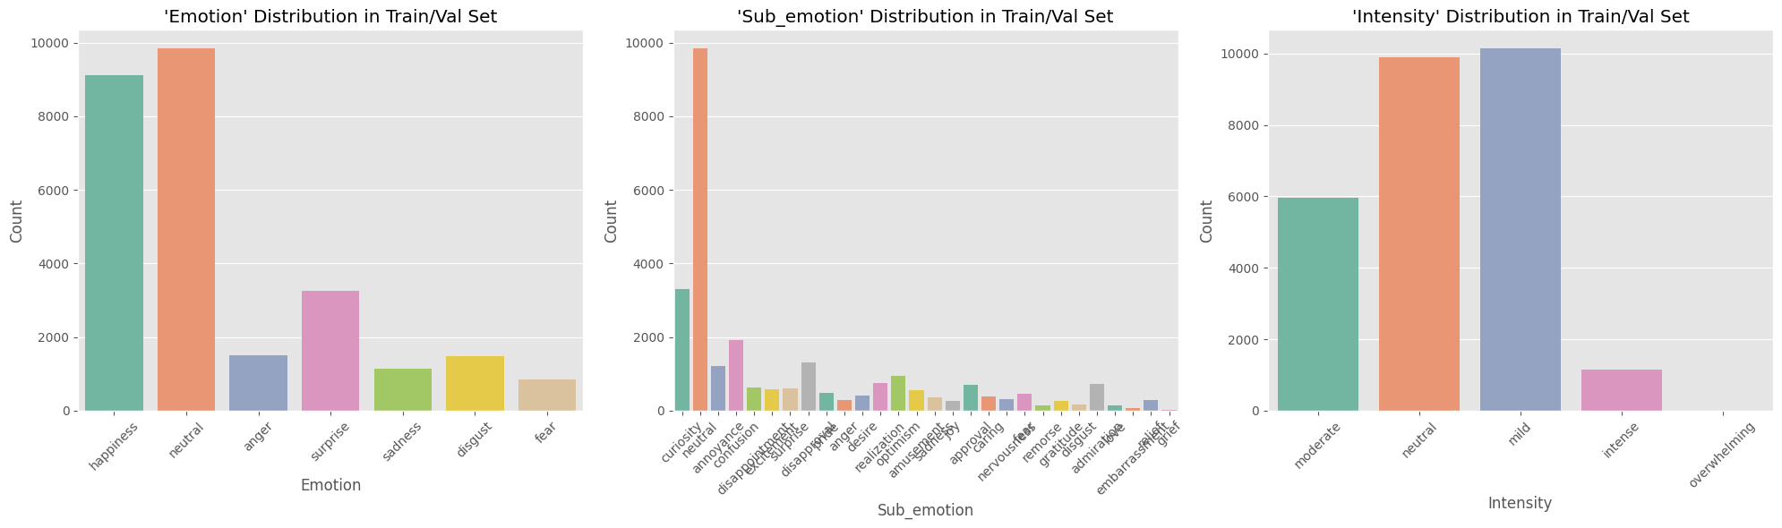
Figure 1: Train Dataset Distribution
The model was trained on a merged dataset from all project groups and evaluated on our group's original test set. Across all tasks — emotion, sub_emotion, and intensity — the dataset shows strong class imbalance, as you can see in Figure 1 above, with neutral and happiness making up nearly 70% of the training data, and fear, sadness, and disgust together under 13%. The imbalance ratio between majority and minority classes reaches 11.5:1. To address this, we applied class weighting, giving higher importance to underrepresented classes (e.g. surprise: 4.54, fear: 1.19).
Further analysis revealed structural and linguistic biases. Minority emotions had greater vocabulary diversity (up to 42%), while majority classes used more repetitive language. Neutral texts were shorter, and sentiment scores aligned with emotional polarity (happiness: +0.15; sadness, anger, disgust: ~–0.04). Figure 2 shows that sub-emotion and intensity labels were unevenly distributed, with neutral having only one sub-emotion and all samples labelled as neutral intensity. Vocabulary overlap between emotions was low (15–35%), highlighting distinct expression styles. These limitations pose key challenges for learning emotional nuance and generalizing across emotion categories.
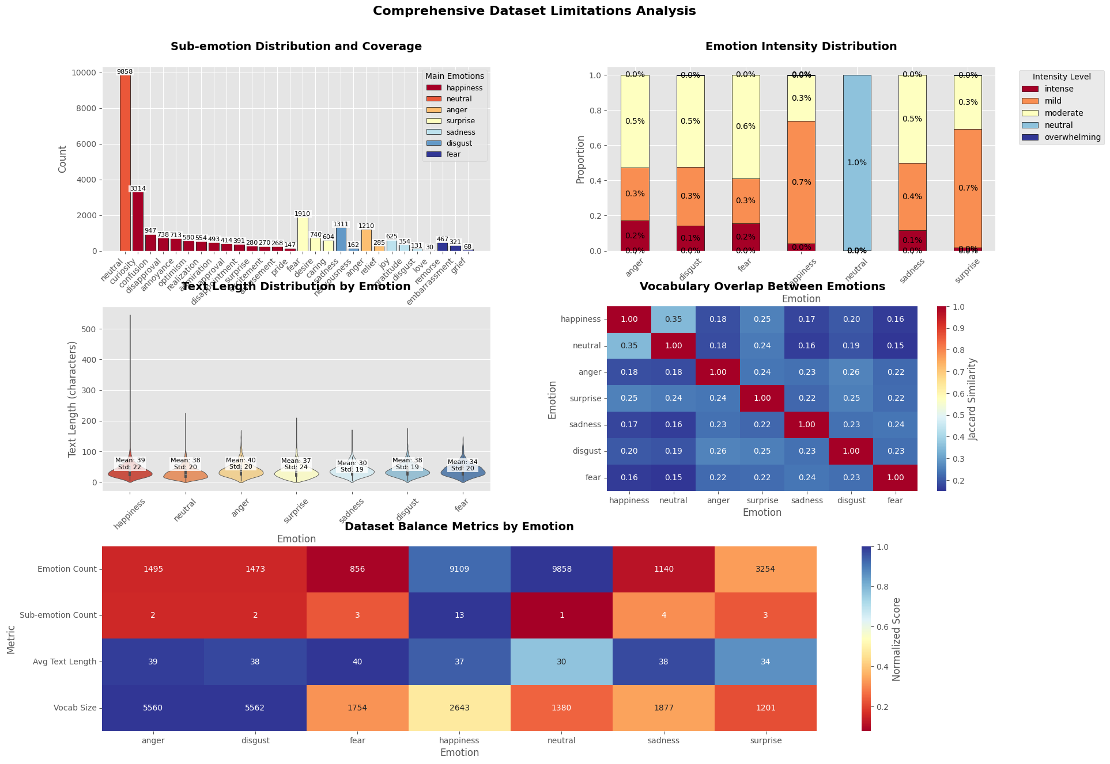
Figure 2: Dataset Limitations Analysis
  - Iteration 1
In Iteration 1, we established a baseline by training the model on raw text only, without any feature extraction inputs. The goal was to map "text" to "emotion", "sub-emotion", and "intensity" while using class weighting to reduce bias toward dominant labels.
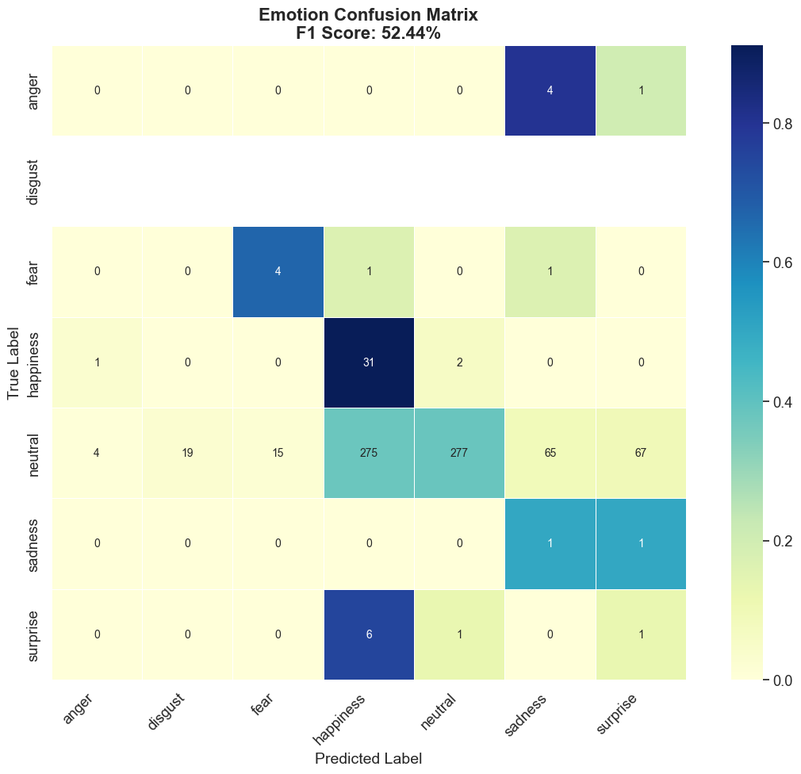
Figure 3: Emotion Confusion Matrix - Iteration 1
The baseline model performed best on sub-emotion prediction (F1: 86.6%), with moderate results for emotion (52.4%) and intensity (41.5%). Figure 4 below shows that accuracy was highest for happiness (91%) and fear (67%), but extremely low for surprise (12%) and anger (0%). In the intensity task, neutral was predicted most reliably (78%), while intense cases saw 0% recall. Combined task accuracy dropped to 22%.
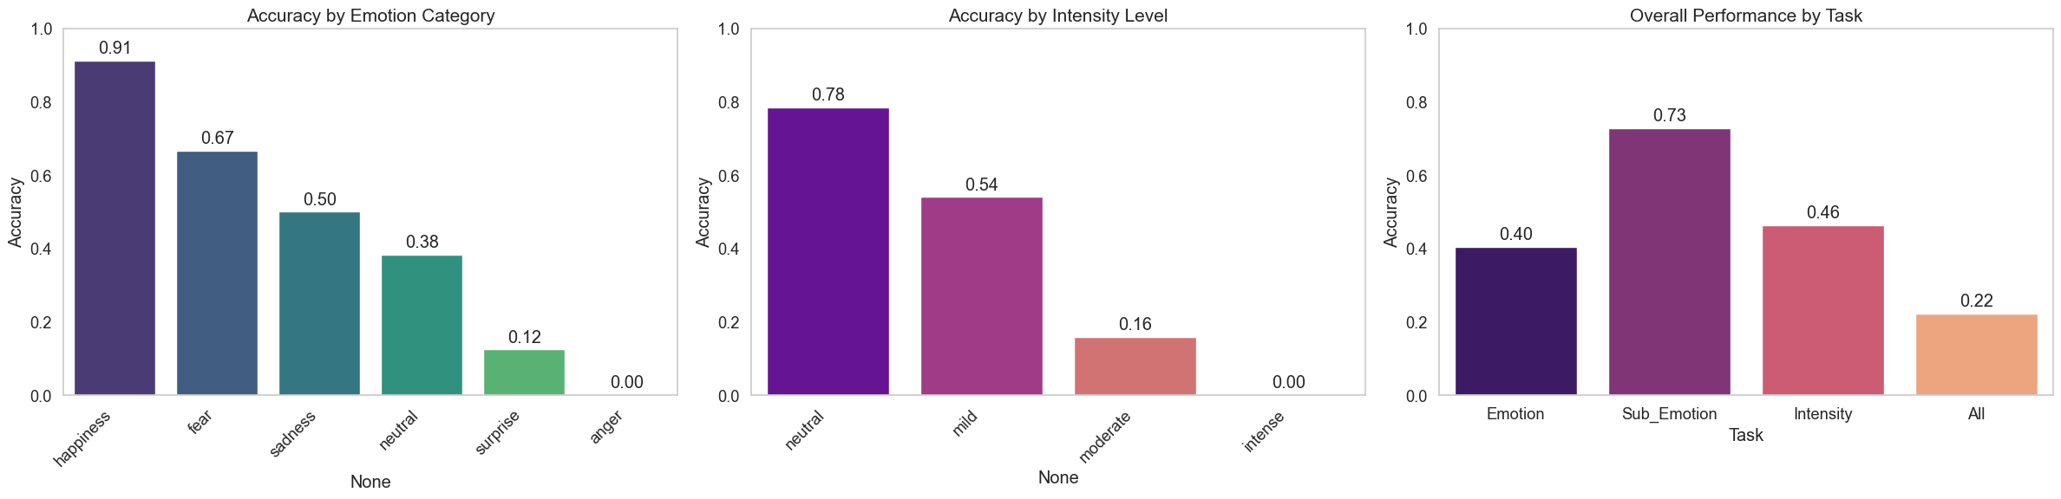
Figure 4: Accuracy - Iteration 1
The emotion confusion matrix in Figure 3 reveals major confusion between neutral, happiness, and sadness, with neutral often misclassified as happiness, fear, or even disgust, despite correct sub-emotion predictions. Sub-emotion outputs heavily defaulted to neutral, while nuanced categories such as pride or nervousness were frequently missed. Intensity predictions also skewed toward mild and neutral, with moderate and intense cases commonly misclassified. This indicates that the model struggles to capture emotional nuance and gradation, particularly in underrepresented or subtly expressed cases—for example, the neutral sentence “Let me hear you say, I want to be here...” was misclassified as happiness, reflecting difficulty in distinguishing emotionally ambiguous content.
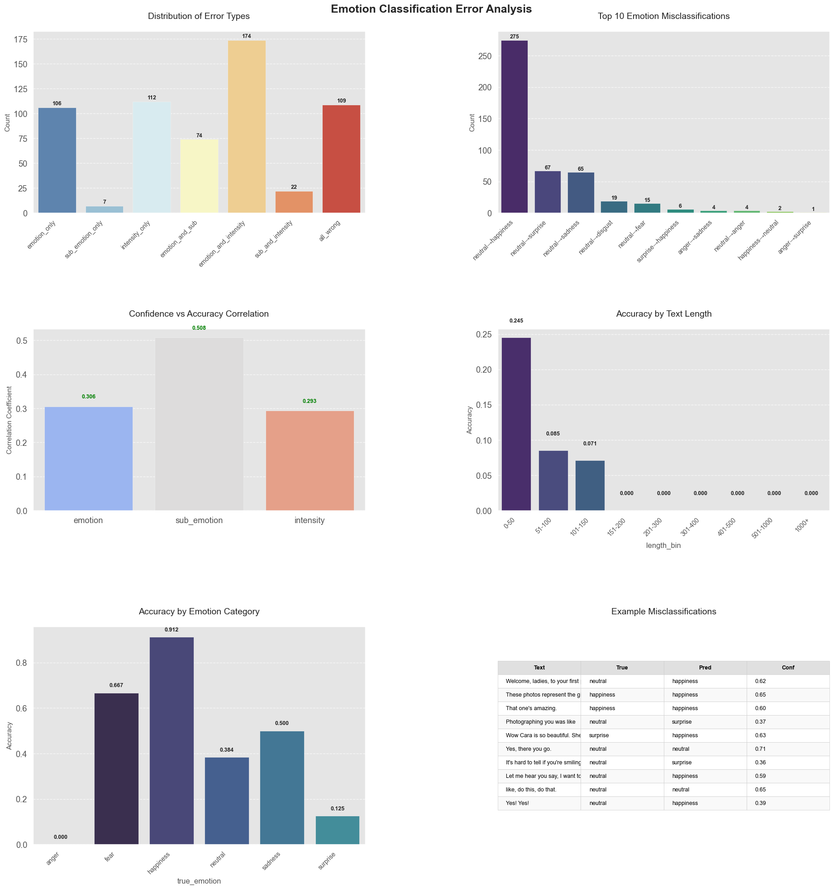
Figure 5: Error Analysis – Iteration 1
Further analysis from Figure 5 above confirmed that neutral-to-happiness confusion was the most frequent error, with 275 instances and an average confidence of 0.552, often triggered by descriptive or mildly positive language. Overall, 73.7% of all errors involved the neutral class, marking it as the most problematic. The model often predicted "happiness" for neutral cases with positive tone, even when sub-emotion and intensity were correct. Accuracy was highest for very short texts (under 50 characters) but dropped to zero beyond 150 characters, showing sensitivity to input length. Confidence-to-accuracy correlation was strongest for sub-emotion (0.508), with lower values for emotion (0.306) and intensity (0.293).
In terms of hierarchical performance, demonstrated by Figure 4, sub-emotion predictions were the most accurate (0.727), while intensity lagged behind (0.463), with intense cases entirely missed. Predictions skewed toward mild and neutral, indicating low sensitivity to strong emotions. These patterns highlight the need for data augmentation, contrastive learning, and hierarchical attention to better handle nuanced or overlapping emotional expressions.
  - Iteration 2
In the second iteration, we extended the baseline by integrating linguistic and semantic features—including POS tags, TextBlob sentiment, VADER polarity, and TF-IDF vectors—to improve the model's ability to distinguish between neutral and happiness emotions, a key weakness in Iteration 1.
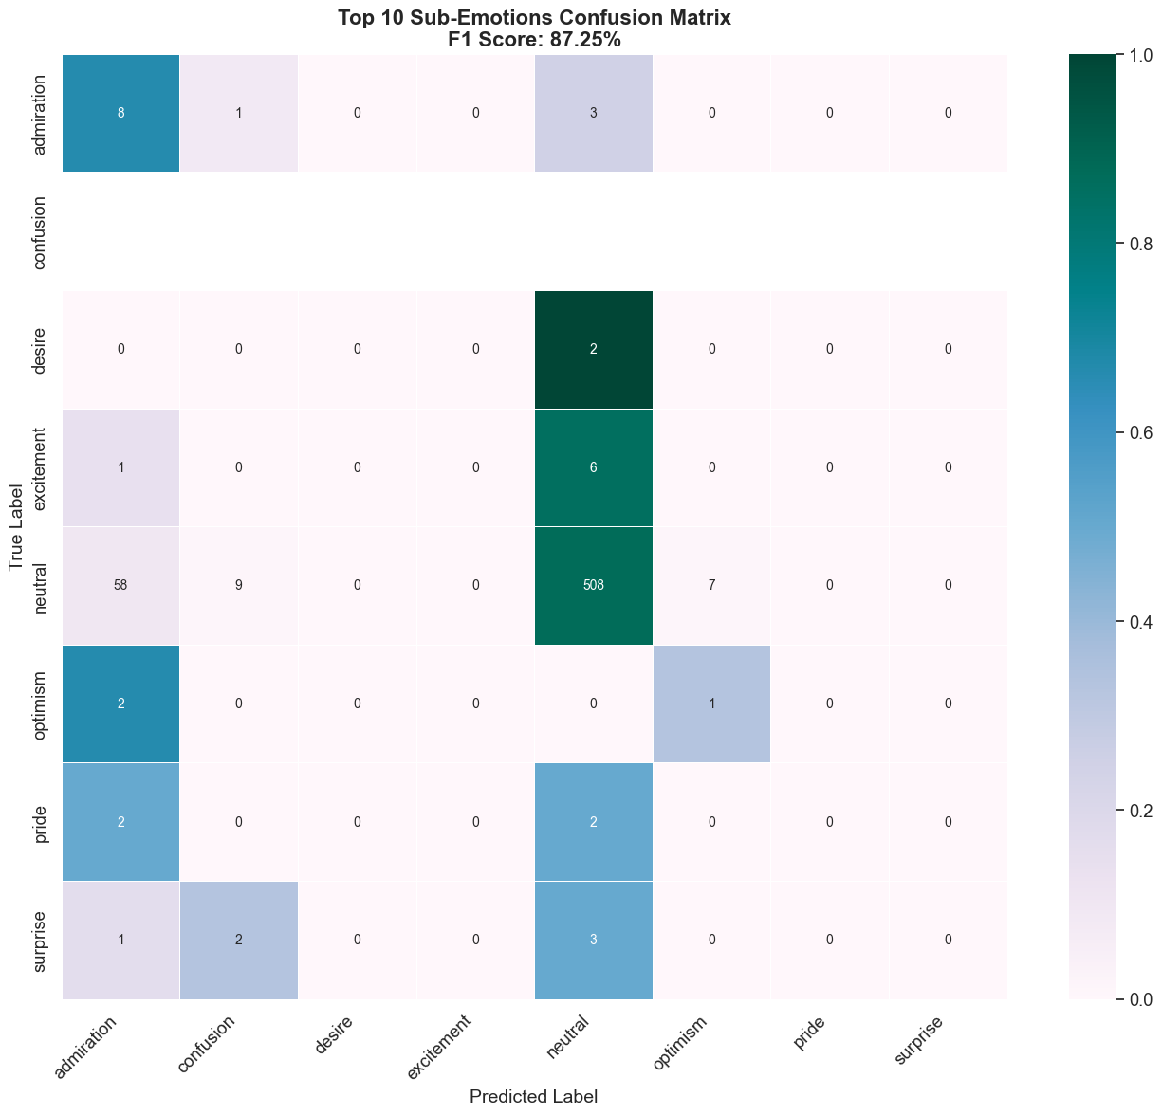
Figure 6: Sub-emotion Confusion Matrix – Iteration 2
While the sub-emotion prediction remained strong (F1: 87.3%), see Figure 6 above, overall improvements were modest. Emotion classification reached an F1 score of 52.7%, with high accuracy for happiness (85%), but persistent confusion between neutral, disgust, and surprise. Neutral continued to dominate in sub-emotion predictions (70% recall), but nuanced labels like curiosity, desire, and pride remained hard to detect. Intensity performance saw a slight uptick (F1: 42.6%), with neutral intensity reaching 76% accuracy, shown in Figure 7. However, intense expressions remained undetected (0% recall), and moderate levels were often mislabelled as mild or neutral.
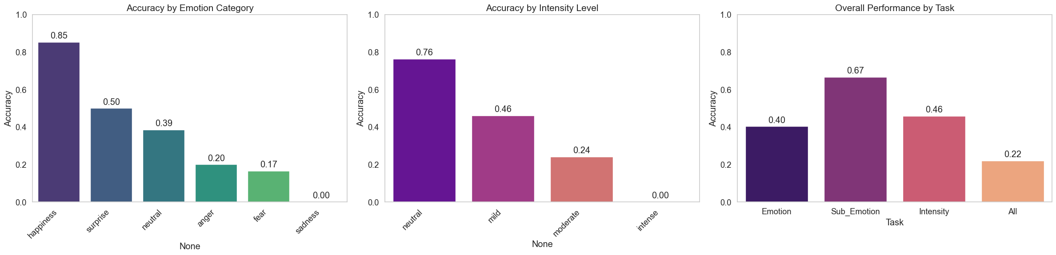
Figure 7: Accuracy - Iteration 2
Misclassification patterns largely mirrored Iteration 1, with neutral utterances—such as “I forgive you”—often misclassified as emotional (e.g., happiness), despite correct sub-emotion and intensity predictions, showing that the model still struggles with emotional subtlety, especially in short or unclear texts.
Figure 8 demonstrates that the integration of linguistic features led to a 28% reduction in the most frequent error—misclassifying neutral as happiness—which dropped from 275 to 197 instances. However, the average confidence in these incorrect predictions remained nearly unchanged at 0.539, indicating the model remains moderately uncertain in ambiguous cases.
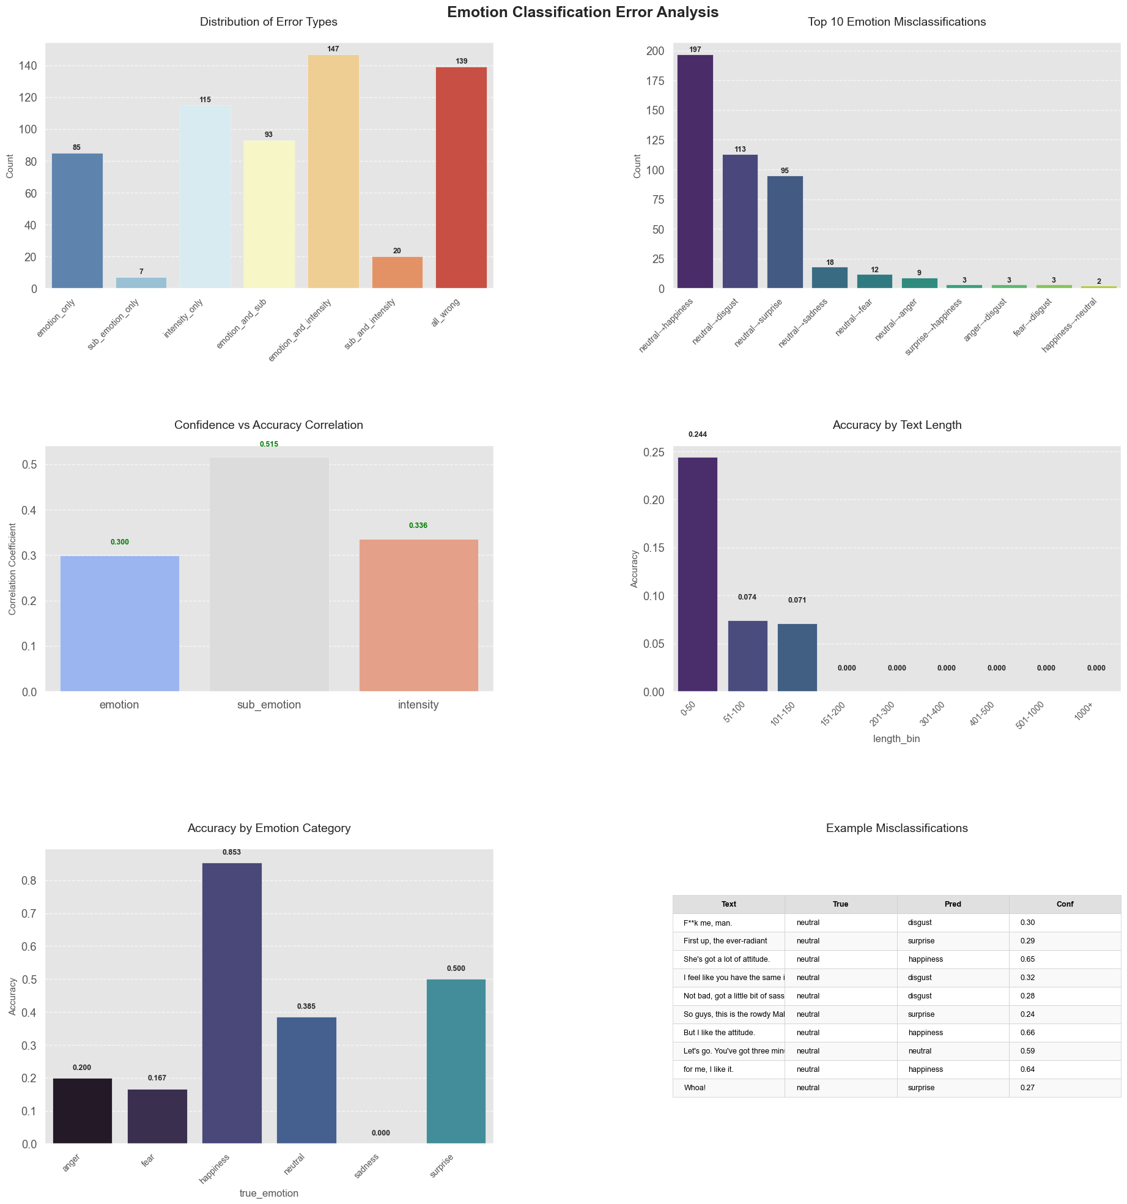
Figure 8: Error Analysis - Iteration 2
Despite these improvements, the overall accuracy (Figure 7) stayed consistent at 0.22, suggesting that while one error type improved, others may have emerged. The neutral class remained the most error-prone, responsible for 444 out of 606 total errors (73.3%). Notably, sub-emotion accuracy dropped slightly (from 0.727 to 0.667), and intensity accuracy remained stable (0.458 vs 0.463), highlighting the challenge of balancing improvements across hierarchical levels. Performance by text length remained unchanged, and confidence-to-accuracy correlations were strongest for sub-emotion (0.515), followed by intensity (0.336) and emotion (0.300).
These results suggest that while feature extraction helped mitigate dominant error patterns, further progress required better handling of nuanced and long-form expressions, which can be addressed through hierarchical attention, semantic augmentation, and contrastive learning.
  - Iteration 3
In the third iteration, we extended the feature pipeline from Iteration 2 by adding EmoLex (NRC Emotion Lexicon) features to better capture emotional nuances in text. This aimed to address the ongoing confusion between neutral and happiness emotions and improve upon the previous iteration’s 22% accuracy plateau.
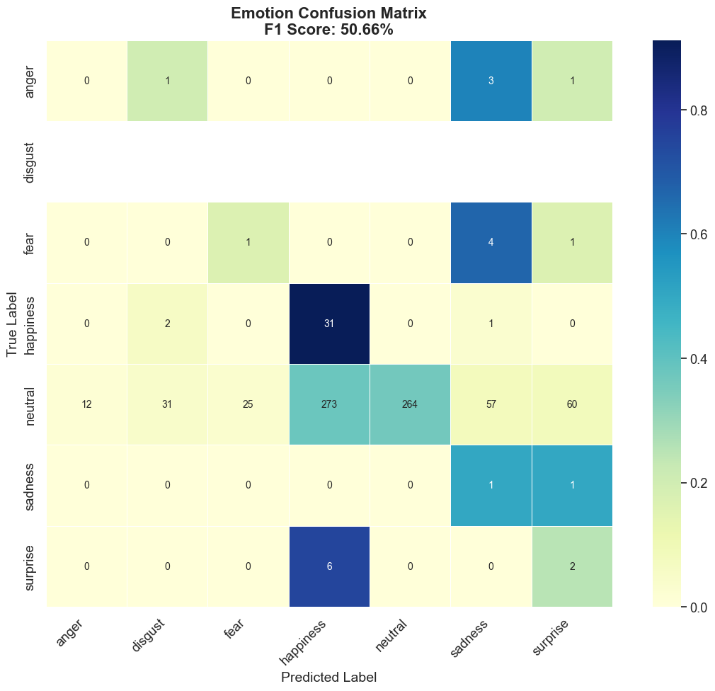
Figure 9: Emotion Confusion Matrix – Iteration 3
This change led to a slight drop in emotion classification performance, with the F1 score decreasing from 52.7% to 50.7% and accuracy falling from 0.40 to 0.38. While happiness accuracy improved from 85% to 91%, neutral continued to be the most misclassified, with 273 instances wrongly labelled as happiness—a rise from 197 in Iteration 2. Misclassifications also spread more toward sadness (57) and surprise (60), as depicted in Figure 9, showing that neutral utterances continued to be interpreted as overtly emotional.
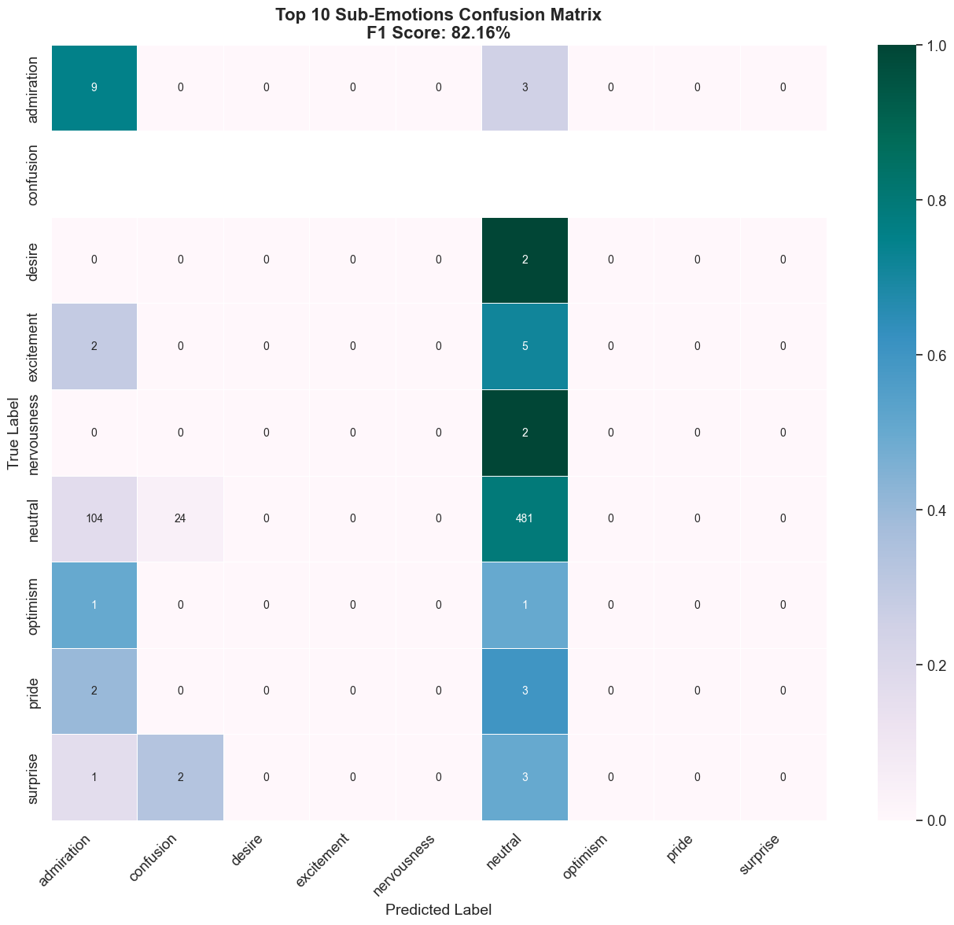
Figure 10: Sub-emotion Confusion Matrix – Iteration 3
Sub-emotion performance also declined, with the F1 score falling from 87.3% to 73.4% and neutral recall dropping slightly from 70% to 66%. Nuanced sub-emotions like optimism, desire, and pride remained undetected, shown in Figure 10 above. However, the model showed some increased sensitivity to admiration, which appeared frequently as a predicted label for emotional misclassifications. Intensity classification remained stable (F1: 42.6% → 42.7%), with the best performance again in the neutral class (71% accuracy, down from 76%), followed by mild (51%), and moderate (24%). Intense expressions were still not detected (0% recall).
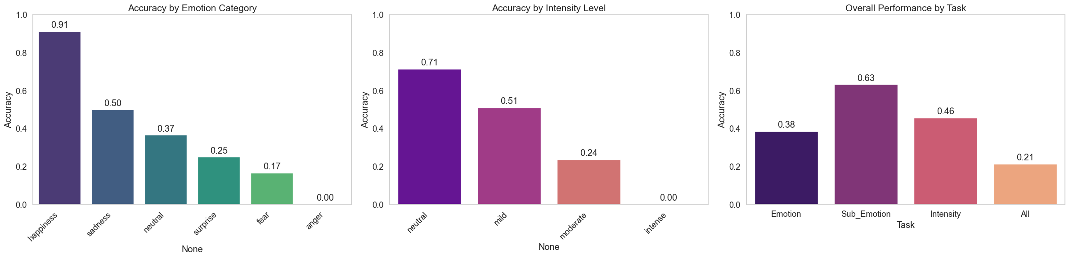
Figure 11: Accuracy - Iteration 3
Figure 11 demonstrates that overall performance across tasks showed little change, with total accuracy slipping from 0.22 to 0.21. Neutral-to-happiness misclassifications shown below in Figure 12 accounted for nearly 75% (458 of 611) of all errors, reinforcing neutral as the most unstable class. The model also became more confident in its mistakes, with average confidence in misclassifications rising to 0.585 (from 0.539), indicating a shift toward overconfident but wrong predictions. This was mirrored in the sharp drop in confidence-to-accuracy correlation for emotion predictions (0.082, down from 0.300), while sub-emotion (0.510) and intensity (0.320) correlations stayed stable.
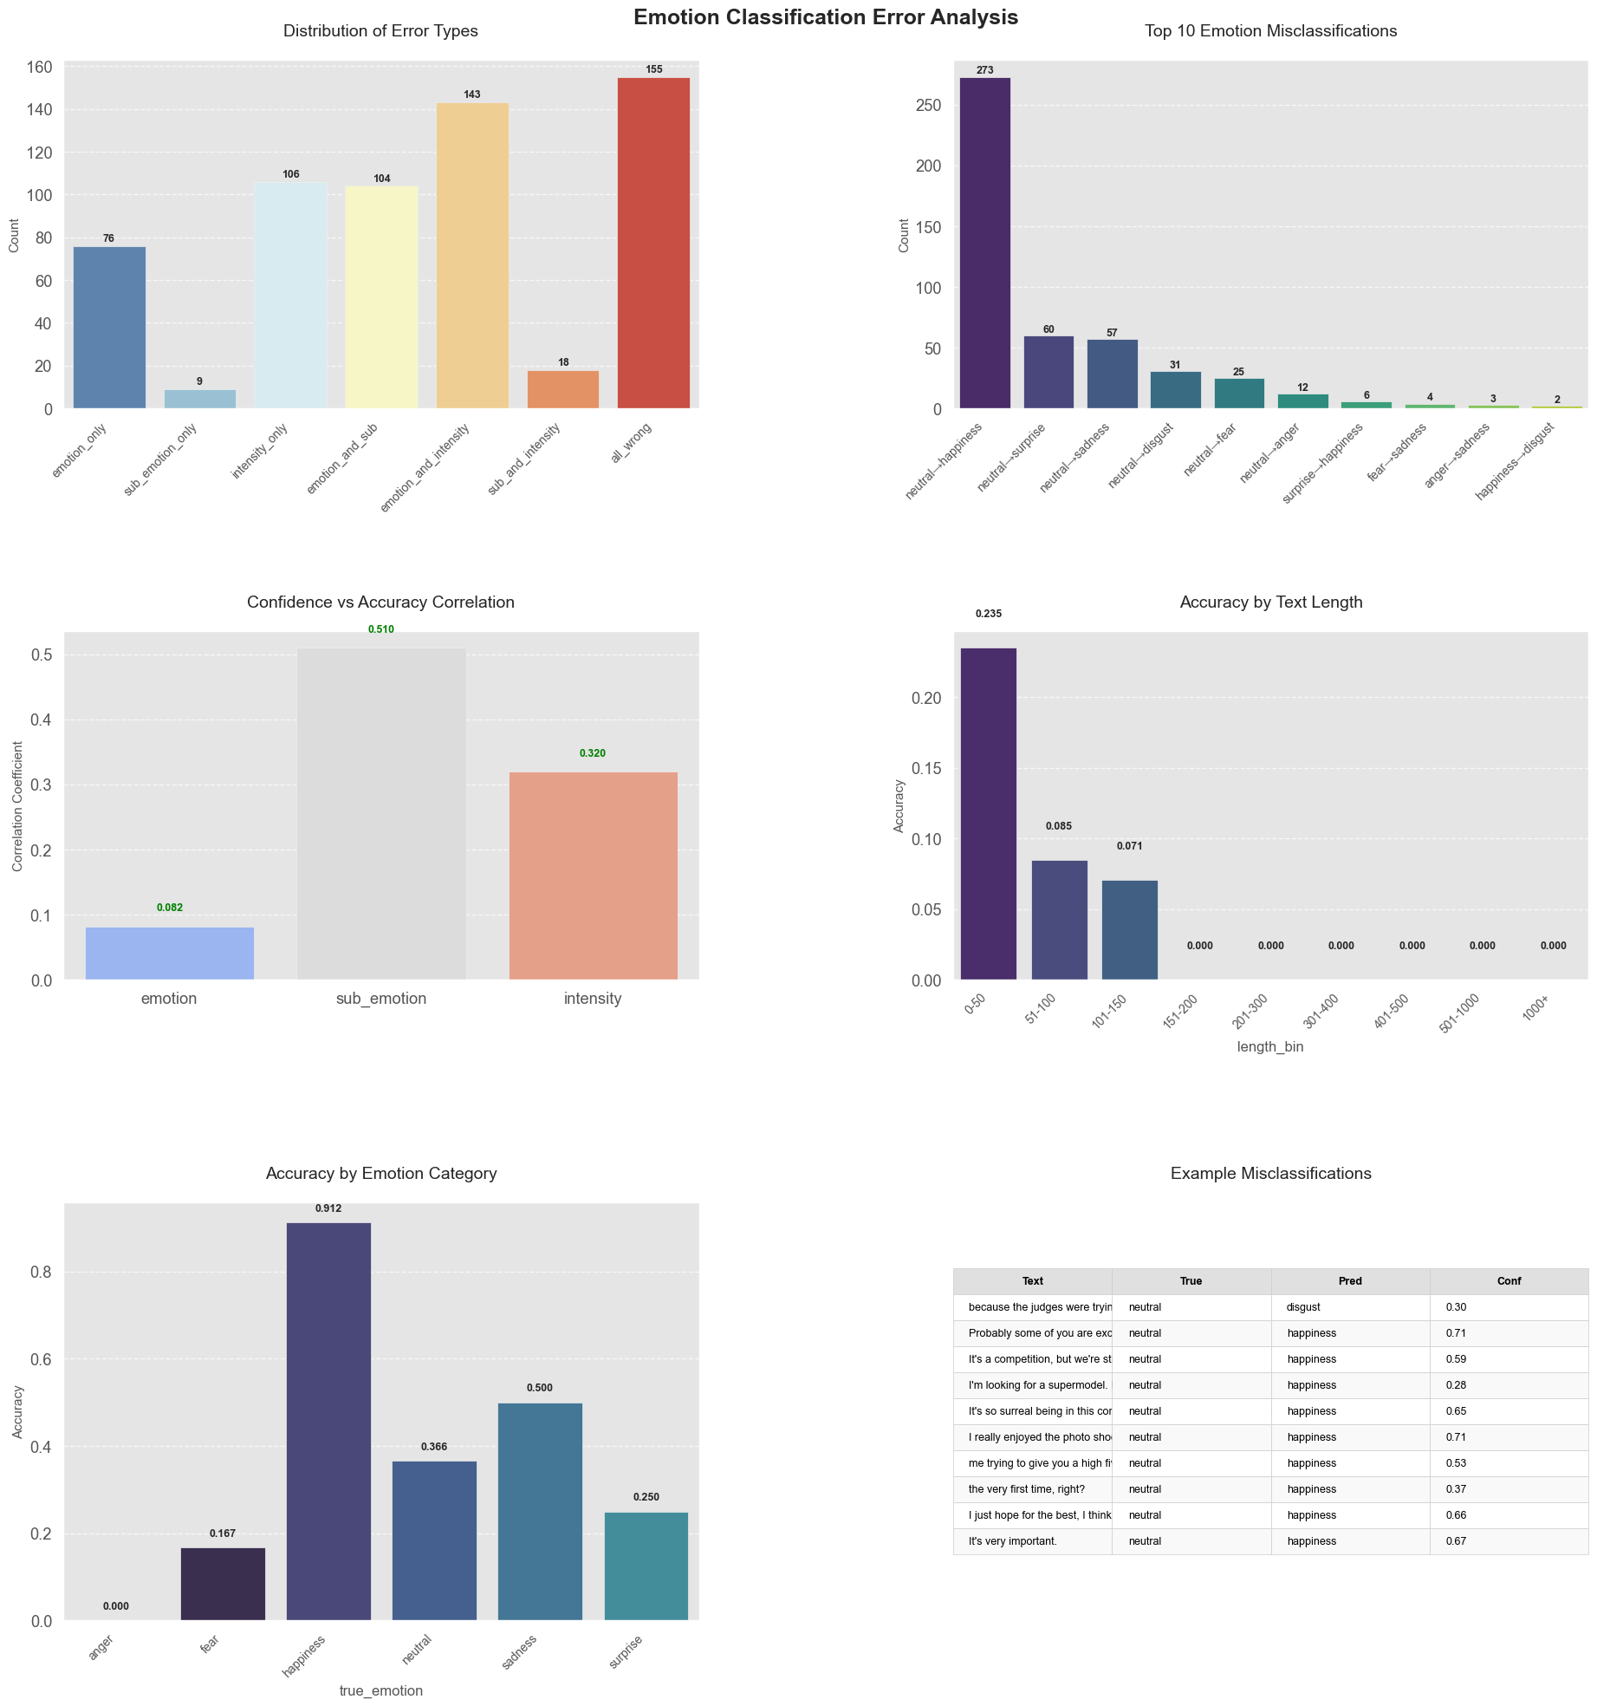
Figure 12: Error Analysis - Iteration 3
Misclassifications were often triggered by positive phrasing in neutral statements, such as “because I’m a very hardworking girl” or “this is a dream come true”— which were frequently mislabelled as happiness with sub-emotions like admiration. Neutral comments about effort or context showed similar errors, revealing an overreliance on sentiment cues. Accuracy remained limited to very short inputs (<50 characters), reinforcing earlier trends. Overall, the model became more decisive but remained misaligned with emotional nuance, underscoring the limits of lexicon-based features.
  - Iteration 4
In the fourth iteration, we returned to the simpler baseline setup from Iteration 1, removing all handcrafted features to reduce complexity. Instead of adding new input features, we introduced a post-processing method that mapped predicted sub-emotions to their corresponding parent emotions. This hierarchical correction aimed to leverage the model’s stronger sub-emotion predictions to refine emotion outputs, addressing the persistent neutral-to-happiness misclassification issue and improving overall emotion classification without retraining the model.
The introduction of sub-emotion–to–emotion mapping led to a substantial performance boost. Emotion accuracy jumped from 0.38 to 0.734, and the weighted F1 score reached 0.801—the highest across all iterations. The number of neutral predictions increased to 597, while happiness dropped to 144, directly addressing the overprediction seen in earlier rounds. The predicted emotion distribution aligned more closely with the true labels, especially for the dominant neutral class (74.2% predicted vs. 93.2% true), which can be seen in Figure 13 below.
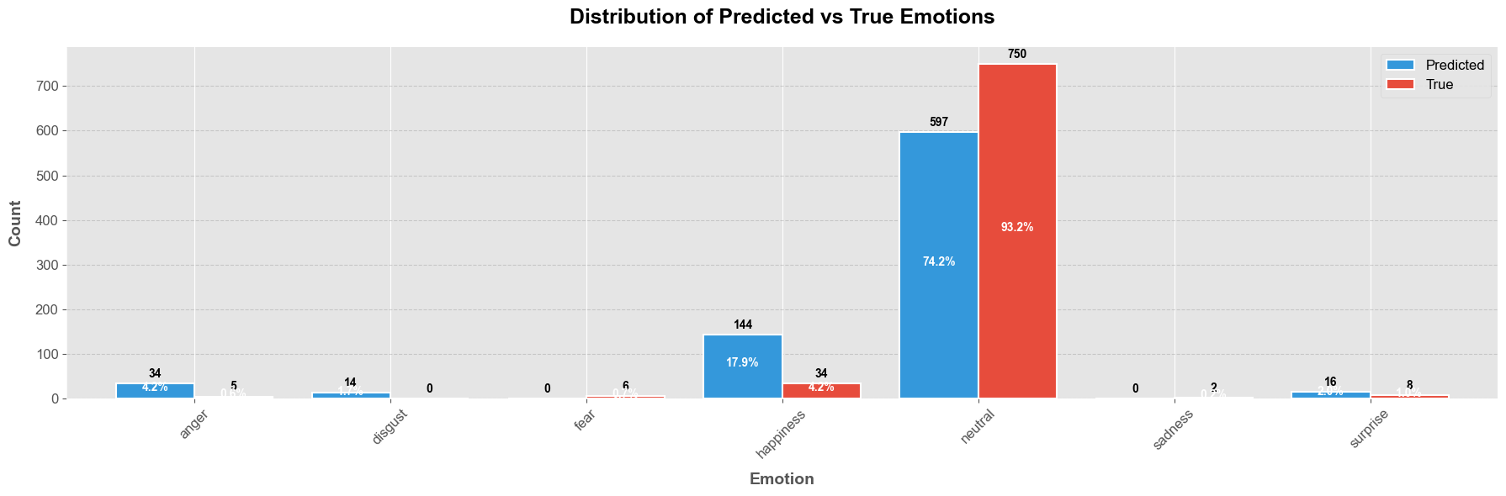Figure 13: True vs. Predicted Label Distribution - Iteration 4
While classification of neutral emotions improved significantly—achieving precision of 0.96 and an F1 score of 0.85— gains came at the cost of sensitivity to minority emotions. Happiness recall dropped to 41%, and classes like fear, sadness, and disgust showed near-zero recall, which is evident in Figure 14. The model also achieved stronger balance between precision (0.8995) and recall (0.7342), contributing to a lower cross-entropy loss of 1.4313. These results demonstrate that hierarchical post-processing, even without additional features or retraining, can meaningfully improve top-level emotion predictions, especially in the face of class imbalance.
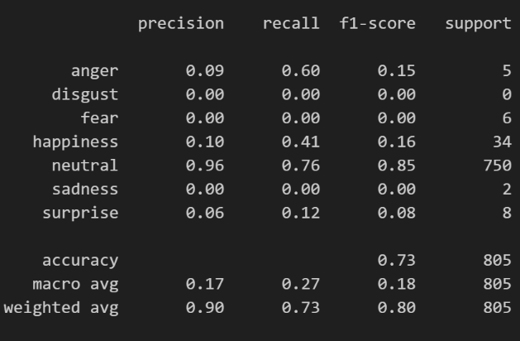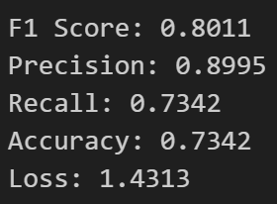
Figure 14: Classification Report - Iteration 4
However, Figure 15 shows that neutral-to-happiness remained the top error with 275 instances, making up nearly 45.5% of all mistakes. Many involved short, ambiguous statements (e.g., “Yes!”, “Good job”), often paired with sub-emotions like admiration, leading to consistent overprediction of happiness. These errors were made with moderate confidence (avg: 0.552), slightly lower than in Iteration 3 (0.585), indicating the model was still uncertain in borderline cases. Confidence-to-accuracy correlation remained strongest for sub-emotion (0.508), while emotion (0.306) and intensity (0.293) correlations were moderate.
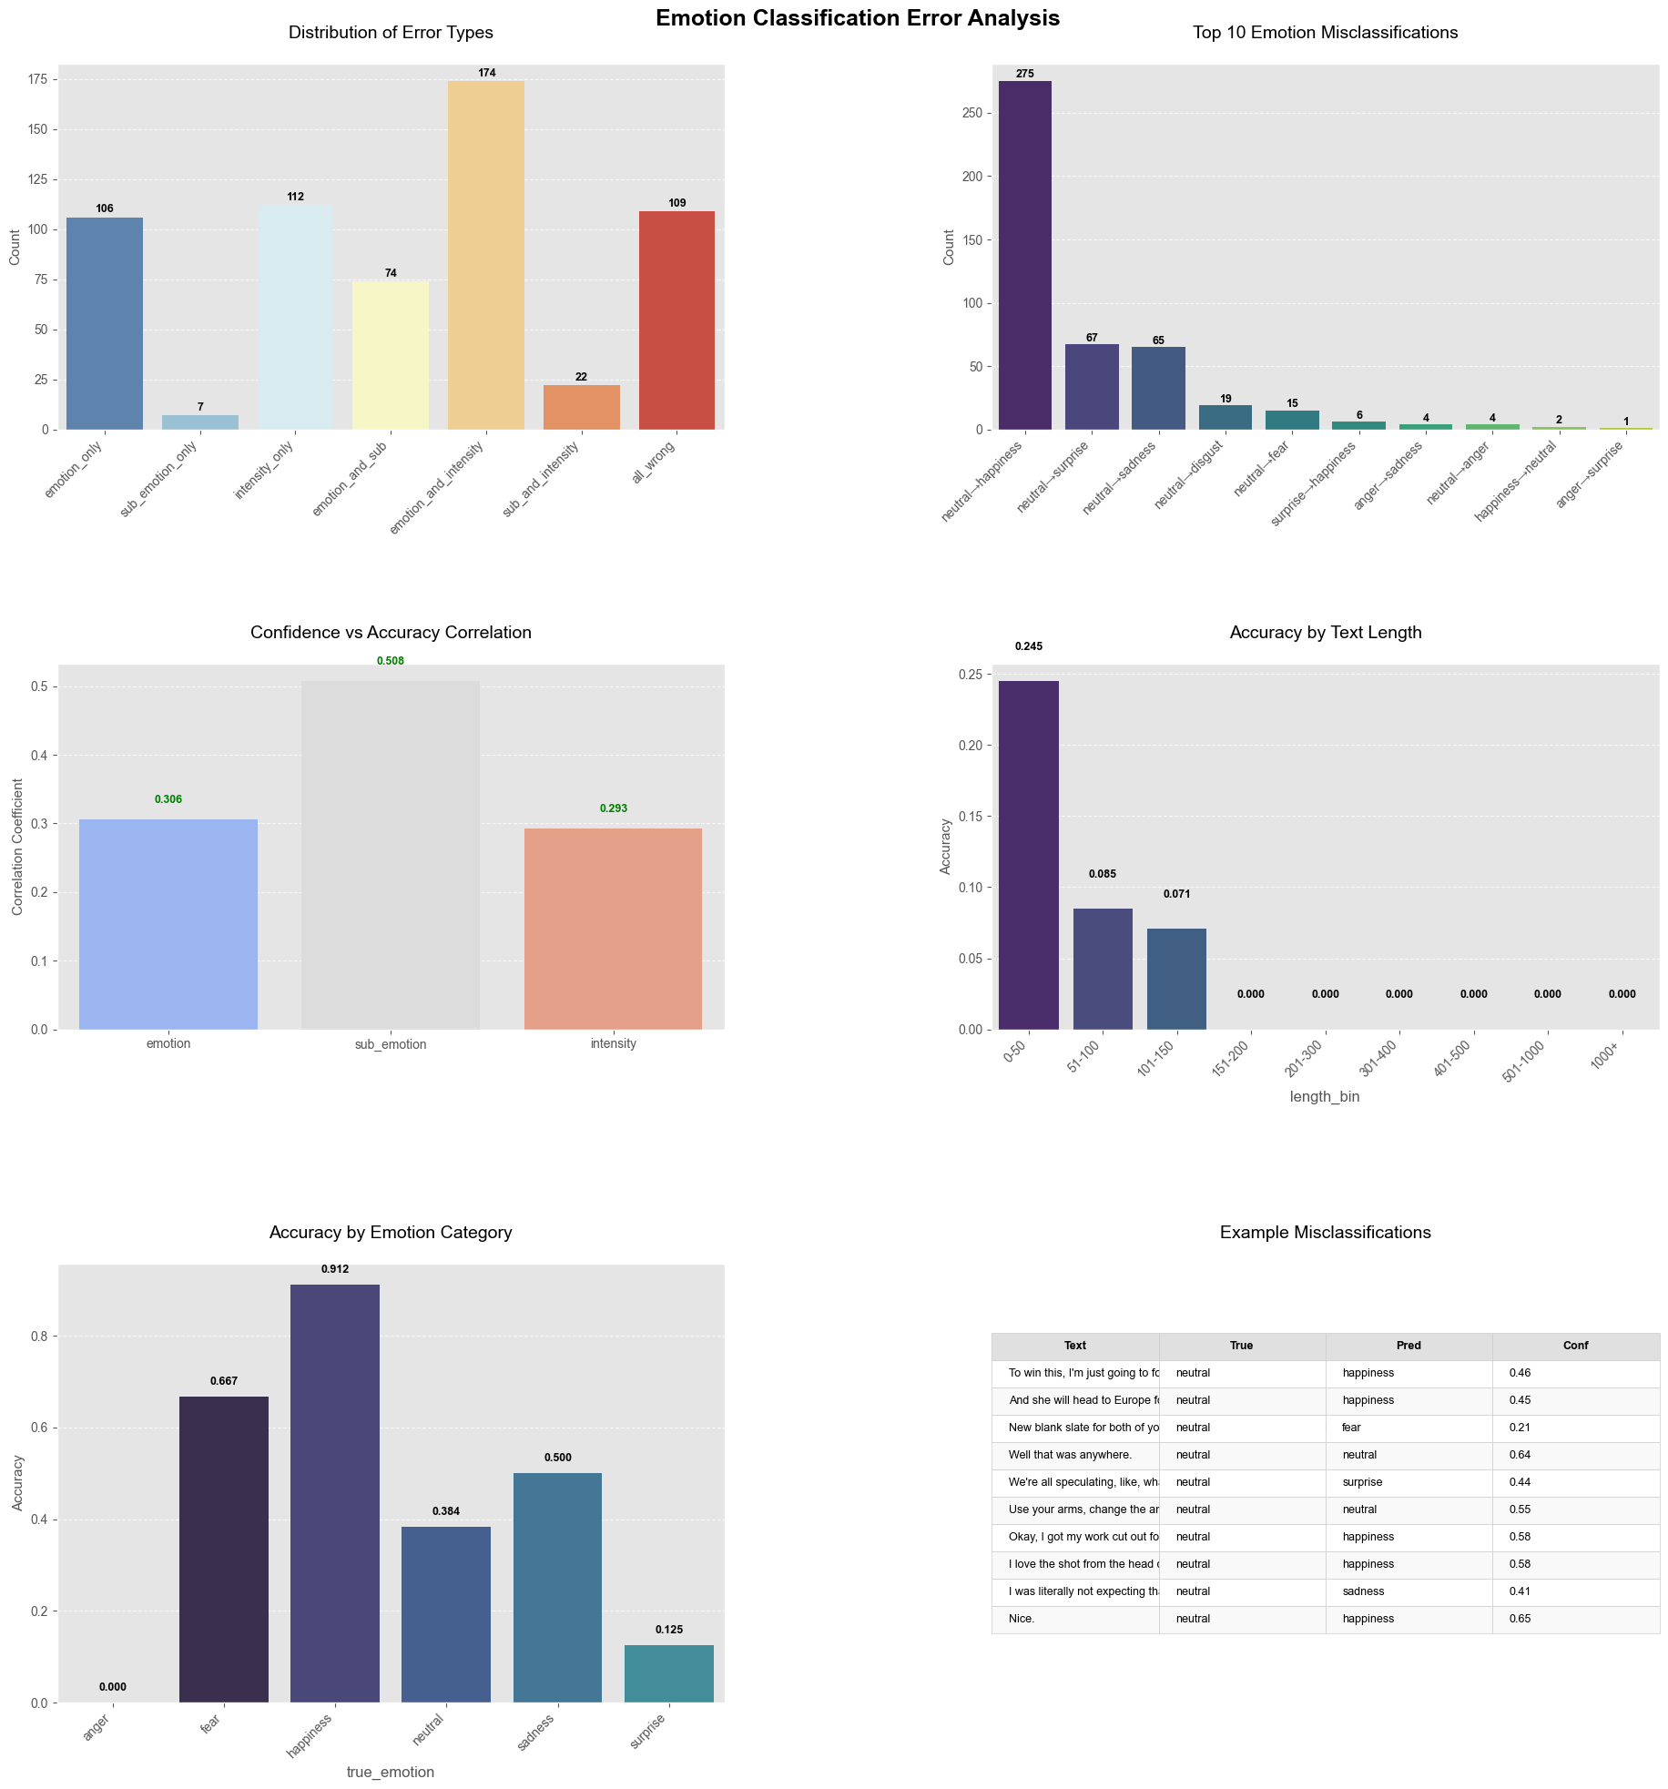
Figure 15: Error Analysis - Iteration 4
Despite improvements in top-line metrics, the macro F1 score remained low (0.18), and errors remained concentrated in the neutral class. Performance was still limited to very short inputs (<50 characters), reinforcing earlier findings that emotional nuance and minority class detection remain unresolved challenges.
  - Iteration 5
In Iteration 5, we aimed to improve model robustness and minority class performance through two key changes: applying class-targeted text augmentation to increase representation of underrepresented sub-emotions, and using the raw university-provided test set instead of the filtered version. The raw set offered a broader and more balanced distribution of emotion classes, enabling more rigorous and realistic evaluation of model performance.
To build on the best results from Iteration 1, we retained the DeBERTa-v3-small backbone and reintroduced TF-IDF and EmoLex features, this time alongside the augmented dataset. We simplified intensity to three levels (mild, moderate, strong) and trained a custom BERT classifier from scratch with the updated data and features—aiming to address class imbalance and overfitting while improving generalization.
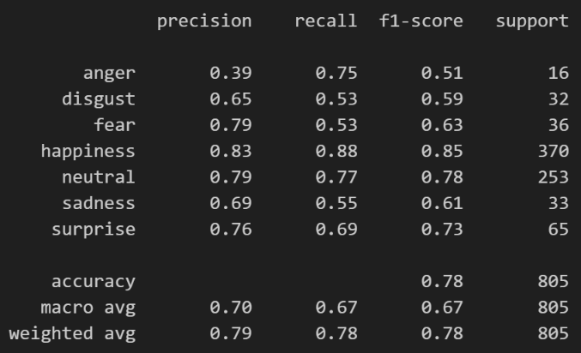
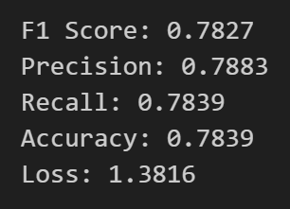
Figure 16 proves that the model achieved an emotion classification accuracy of 0.784 and a weighted F1 score of 0.783, closely matching the performance peak seen in Iteration 4. However, unlike the previous round—where neutral dominance inflated scores—this result reflects a more balanced distribution across all emotions. The macro F1 score rose sharply to 0.67 (from 0.18), signalling improved performance on minority classes. Happiness (F1: 0.85) and neutral (F1: 0.78) remained strong, while surprise (0.73) and fear (0.63) saw marked improvements. Even anger, previously undetectable, reached 0.51, indicating a more equitable treatment of emotional classes. The overall loss decreased to 1.34, confirming stronger alignment between predictions and true labels.
Figure 16: Classification Report - Iteration 5
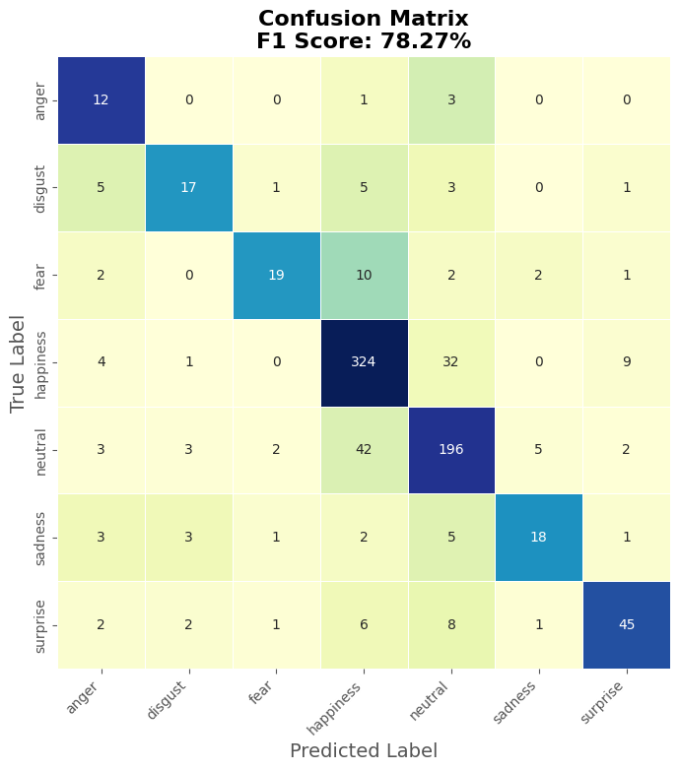
Figure 17: Emotion Confusion Matrix - Iteration 5
Error analysis showed reduced confusion between neutral and happiness, and misclassifications were no longer dominated by a single error type. The confusion matrix in Figure 17 above confirmed more distributed mistakes, with fewer false positives in short, ambiguous inputs. This shift suggests that data diversity and augmentation strategies not only improved class balance but also helped the model develop finer distinctions between similar expressions. While neutral still posed challenges, the model was less biased toward it, and accuracy extended beyond the shortest input lengths—marking a meaningful leap in robustness and generalization.

  - Conclusion
Over five iterations, our approach evolved from simple baseline modelling to sophisticated post-processing and data-driven strategies. While early feature engineering (Iterations 2–3) offered limited gains, the real breakthrough came in Iteration 4, where hierarchical emotion mapping capitalized on the model’s high sub-emotion accuracy to dramatically boost overall emotion classification (F1: 0.801).
In Iteration 5, we shifted focus to data augmentation and reinstated key features (TF-IDF, EmoLex), yielding a robust, well-generalized model (F1: 0.783) with improved performance across minority classes and more balanced predictions.
The journey highlights a key insight: simpler architectures paired with strategic post-processing or data-centric approaches can outperform more complex feature-heavy pipelines. By learning from performance patterns and error behaviour at each stage, we systematically refined our model to be not just more accurate, but also fairer and more adaptable across real-world emotional expressions.

  - Disclosure
ChatGPT (OpenAI, 2024) was used solely to refine language and improve clarity in this report. All interpretations, findings, figures and conclusions remain our own. (OpenAI. (2024). ChatGPT (April 2024 version) [Large language model]. https://openai.com/chatgpt)

